

**FASHION SHOP ONLINE**

**Project Assignment Solution**

*(Ban hành kèm theo Quyết định số 480 /QĐ-ĐHFPT ngày 4 tháng 5 năm 2021 của Hiệu trưởng Trường Đại học FPT)*

– Hanoi, May 2021 –

**Table of Contents**

I. Overview 3

1. Introduction 3

2. System Functions 4

3. Entity Relationship Diagram 5

4. Common Requirements 5

II. Functional Requirements 6

1. <<Feature Name 1>> 6

a. <<Function Name 1>> 6

b. <<Function Name 2>> 6

2. <<Feature Name 2>> 6

# I. Overview

## 1. Introduction

The online clothing shopping system is a new Web application that replaces the real-life selection processes, making it easier for customers to choose and to pay conveniently. With a diverse product development system, customers do not have to go to the place to choose but can stay at home and comfortably choose for themselves suitable models. Especially during the current outbreak of Covid-19 epidemic, prevention work becomes even more effective. This system is expected to develop after updates with new features and promises to be completed as soon as possible to introduce to consumers.

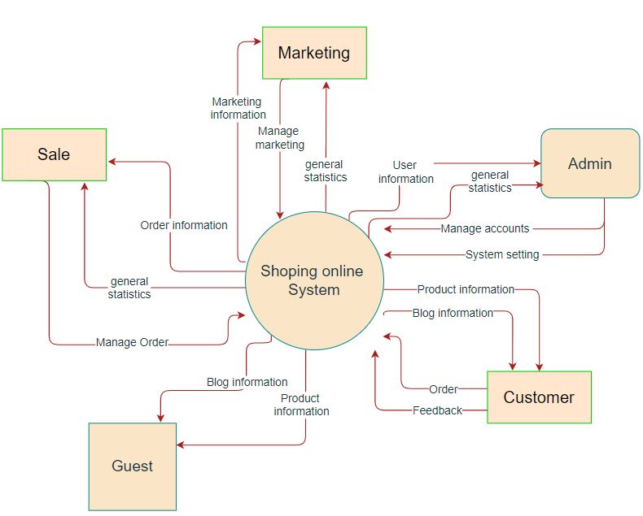

* Marketing information: Posts list, Sliders list, Products list, Feedbacks list.

## 2. System Functions

#### a. Screen Flow

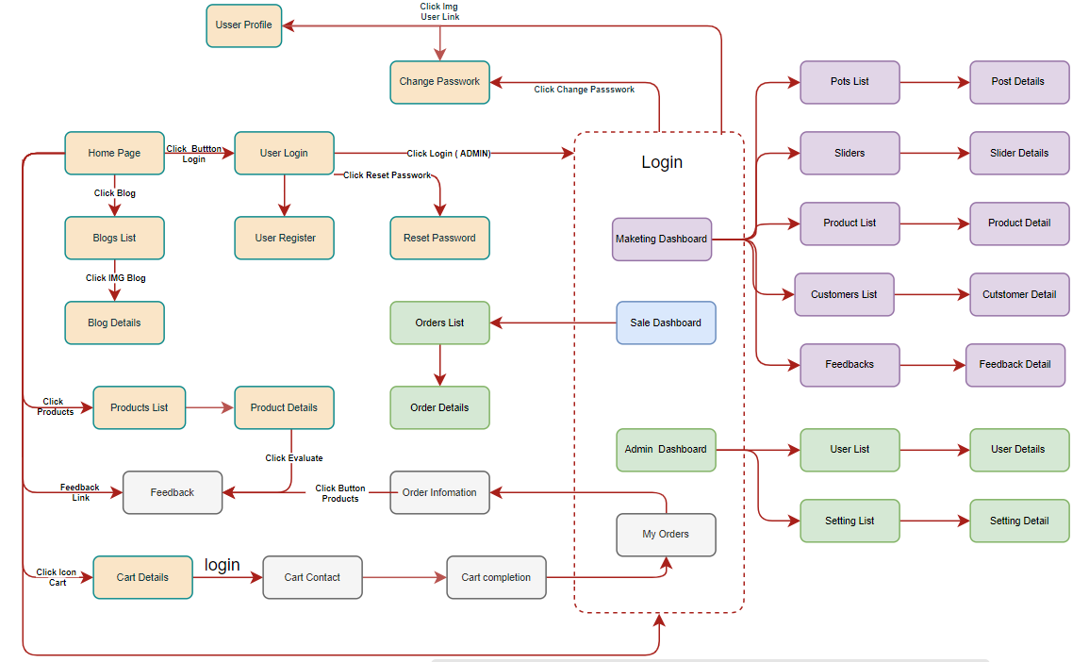

#### b. Screen Details

|  |  |  |  |
| --- | --- | --- | --- |
| **#** | **Feature** | **Screen** | **Description** |
| 1 | Public | Home Page | Show sliders, hot posts, featured products + the slider with the latest posts, static contacts/links  - Shown slider information includes its image and title; the user is redirected to the slider's backlink on his/her clicking  - Shown post information includes its thumbnail, title, brief-info; the user is redirected to the post's details on his/her clicking  - Shown product information includes its thumbnail, title, brief information; the user is redirected to the product's details on his/her clicking |
| 2 | Public | Blogs List | This is a pop-up screen which allows the user to enter email & password to login; on this page, there are also links for user to register new information or reset the password for the case s/he forget it |
| 3 | Public | Blog Details | This is a pop-up screen which allows the user to register to the system by inputting following information: full name, user title (Mr, Mrs, Ms,..), email, mobile, address; User then needs to verify by clicking the link sent via email to him/her before being able to access the system |
| 4 | Public | Products List | The user input his/her email to receive the reset password link. This link is sent to the user's email for his/her password resetting.  - On clicking the link, the user is redirected to the password resetting page in which s/he input new password (twice) for the system access  - Note that the link is only available for a specific time duration as configured in the system config file. |
| 5 | Public | Product Details | Implementation of authorization mechanism in the system, including the specify the role of logged-in user, his/her authorized page links (building the displayed menu items (in the front end) and preventing unauthorized access via enter the links directly) |
| 6 | Public | Cart Details | This is a pop-up screen which allows the user to edit his/her profile information, including the registered ones & the avatar image. Please note that s/he is not allowed to change the email |
| 7 | Public | Cart Contact | This is a pop-up screen which allows the user to change his/her password by inputting his current password as well as new password (twice) |
| 8 | Public | Cart Completion | Show the posts pagination (sorted by updated date, paginated) + the cider with the post search box, post categories, the latest posts, and static contacts/links; Shown post information includes its thumbnail, title, brief-info; the user is redirected to the post's details on his/her clicking |
| 9 | Public | Feedback | Show post details (including title, author, updated date, category, and post details) + the cider with the post search box, post categories, static contacts/links |
| 10 | Common | User Login | Show the paginated list of posts (include posts' id, thumbnail, title, category, author, featured, and status information):  - The user can filter the post by category, author, status or search by title  - Sortable by title, category, author, featured, or status  - From each post, the user can choose to hide, show, view, edit it  - The page also have the button/link that allows the user to add new post |
| 11 | Common | User Register | Show detailed post information (thumbnail, category, title, brief information, content, flag to turn the featurning on/off, status), from that allow the user to input new post information, view or edit existing post information |
| 12 | Common | Reset Password | Show the paginated list of sliders (including sliders' id, title, image, backlink, status)  - The user can filter the sliders by the status + search by title or backlink  - For each slider, the user can choose to hide, show, edit it |
| 13 | Common | Change Password | Show detailed slider information (image, title, backlink, status, notes) |
| 14 | Common | User Profile | Show the paginated list of registered users (include users' id, full name, gender, email, mobile, role, status):  - The admin can filter the users by gender, role, status  - Allow the admin to search users by full name, email, mobile  - The list is sortable by id, fullname, gender, email, mobile, role, status  - From each user, the admin can choose to view or edit it  - The page also has the button/link that allows the admin to add new user |
| 15 | Common | User Authorization | Show detailed user information (avatar, full name, gender, email, mobile, role, address, status), from that allow the user to add new, view or edit user information  - After adding, new generated login password would be email to the new user  - The admin can only edit/update the role and status of the user |
| 16 | Customer | My Orders | Show the products paginated (sorted by updated date) + the slider with the product search box, product categories, the latest products, and static contacts/links;  - Shown product information includes its thumbnail, title, brief information, original price, and sale price;  - The user is redirected to the product's details on his/her clicking on the product  - The user can choose to add the product to the cart or to feedback on the product by clicking the product's Buy & Feedback buttons responsively |
| 17 | Customer | Order Information | Show product details (including title, category, images, original price, sale price, and product details) + the slider with the product search box, product categories, the latest products, and static contacts/links |
| 18 | Marketing | Posts List | Show the cart details with list of the user's chosen products (including Id, title, price, quantity, total cost) and the total order price + the slider with the product search box, product categories, the latest products, and static contacts/links; The user can  - Change the quantity of each product: the total cost is automatically adjusted  - Choose to delete/remove product by clicking on the deleting icon  - Click the Choose More Product button to go to Products List page  - Click the Check Out button to go to the Cart Contact page  Please note: the user's chosen products from the last browsing session remain in his/her cart until s/he submits the cart. However, the product prices are updated with the latest prices in the system |
| 19 | Marketing | Post Details | Show the list of users chosen product (including id, title, price, quantity, total cost), the total order price and the receiver information (including full-name, gender, email, mobile, address, notes) for user to edit/input + the slider with the product search box, product categories, the latest products, and static contacts/links  - In case the user has logged in, the receiver information would be filled with the user's information  - The user can click the Change button to come back to the Cart Details page for changing the choosing products, click the Submit button to submit the order before redirecting user to the Card Completion or Error page (due to technical error or any out-of-stock product) |
| 20 | Marketing | Sliders List | This page shows the cart completion notes + the cider with the product search box, product categories, the latest products, and static contacts/links; Before this page is shown:  - The Order status is changed to submitted;  - The product's available quantities are updated accordingly  - The submitted order is assigned automatically to the active salers rotatedly  - If the receiver information (name, email, mobile, gender) is new or changed (checking via the email0, the latest receiver information is stored in the system as latest & historical system contact information (for the marketing's reference later)  - The customer/user would receive the order confirmation & payment guides via his/her email. That information is shown on the page also. The payment information (banking account,...) are taken from the system configuration file |
| 21 | Marketing | Slider Details | On receiving the bought products successfully, the receiver would receive a confirmation email with the guides to feedback on each of the received product; Besides, the user/receive could also give the feedback (on a specific product or general feedback) via the website; The user also call this screen from the system menu on the header;  The feedback information includes contact information (full name, gender, email, mobile), rated star, the attached images and the contact's free-format feedback  The page slider is also shown with the product search box, product categories, static contacts/links; |
| 22 | Marketing | Products List | Show the list of user's orders paginated + the cider with the product search box, product categories, the latest products, and static contacts/links  - Each order includes below information: id, ordered date, product (first product name & number of other products if any), total cost, status;  - On clicking the link under the order id, user would be redirected to the Order Information page |
| 23 | Marketing | Product Details | Show the order details, including the information as below + the slider with the product search box, product categories, the latest products, and static contacts/links  - The order id, order date, total cost, status  - The receiver information: full name, gender, email, mobile  - This list of ordered products, each product includes following information & the links/buttons that allow the user to re-buy or feedback: thumbnail, name, category, unit price, quantity, total cost  For the submitted orders, the user can choose to update (redirect the user to the Cart Details page for that) or cancel the order |
| 24 | Marketing | Customers List | Show statistics of posts, products, customers, feedbacks & the trend of new customers by day for the last 7 days (the start date & end date can be adjustable) |
| 25 | Marketing | Customer Details | Show the paginated list of products (include products' id, thumbnail, title, category, list price, sale price, featured, and status information):  - The user can filter the product by category, status or search by title, brief info  - Sortable by title, category, list price, sale price, featured, or status  - From each product, the user can choose to hide, show, view, edit it  - The page also has the button/link that allows the user to add new product |
| 26 | Marketing | Feedbacks List | Show detailed product information (thumbnail, category, title, brief information, attached images, description, quantity, list price, sale price, flag to turn the featuring on/off, status), from that allow the user to input, view or edit them |
| 27 | Marketing | Feedback Details | Show the list of customers / contacts paginated (include contacts' id, full name, gender, email, mobile, status):  - The user can filter the customers by status + search by full name, email, mobile  - Sortable by full name, email, mobile, status  - From each customer, the user can choose to add new, view or edit it |
| 28 | Sale | Sale Dashboard | Show detailed customer/contact information (full name, gender, email, mobile, address, status), from that allow the user to input, view or edit them (except for the status which is generated automatically - contact, potential or customer)  Besides, the screen also shows the list of customer/contact changes history in the form of a table which includes following columns: email, full-name, gender, mobile, address, updated by, updated date |
| 29 | Sale | Orders List | Show the list of feedbacks paginated (include feedbacks' contact full name, product name, rated star, status):  - The user can filter the feedbacks by status, product, rated star + search by full name, feedback content  - Sortable by full name, product name, rated star, status  - From each feedback, the user can choose to view or change its status |
| 30 | Sale | Order Details | Show the feedback details (contact full name, email, mobile, product, rated star, feedback, images status) from that allow the user to change its status |
| 31 | Admin | Admin Dashboard | Show the trend of success/total orders, and the revenues trends by day for the last 7 days for all or a specific salesperson (the start date, end date, sale, order status can be adjustable) |
| 32 | Admin | Users List x | Show the list of orders paginated  - The list can be shorted by the order date, customer name, total cost, status  - Each order includes below information: id, ordered date, customer name, product (first product name & number of other products if any), total cost, status;  - Allow the users to filter the order by the order date (from, to), sale name, status  - Allow the user to search the orders by order id, customer name  - On clicking the link under the order id, user would be redirected to the Order Details page |
| 33 | Admin | User Details | Show the order details, including the following information:  - Basic order information: order id, customer full name, email, mobile, order date, total cost, sale name, status  - The receiver information: full name, gender, email, mobile, address  - This list of ordered products, each product includes following information: thumbnail, name, category, unit price, quantity, total cost  Sale Manager & the assigned Sale can change the order status & the sale notes  Sale Manager can assign the order to other sale |
| 34 | Admin | Settings List | Show statistics of new orders (success, canceled, submitted), revenues (total, by product categories), customers (newly registered, newly bought), feedbacks (average star: total, by product categories) & the trend of order counts (success, all) by day for the last 7 days (the start date & end date can be adjustable) |
| 35 | Admin | Setting Details | Show the paginated list of settings (include settings' id, type, value, order, status):  - The admin can filter the setting by type, status  - Allow the admin to search settings by value  - The list is sortable by id, type, value, order, status  - From each setting, the admin can choose to view, activate/deactivate, or edit it  - The page also has the button/link that allows the admin to add new setting |
|  |  |  | Show detailed user information (type, value, order, description, status), from that allow the user to add new, view or edit setting information |

#### c. User Authorization

| **Screen** | **Admin** | **Guest** | **Customer** | **Marketing** | **Sale** | **Sale Manager** |
| --- | --- | --- | --- | --- | --- | --- |
| Home Page | x | x | x | x | x | x |
| Blogs List | x | x | x | x | x | x |
| Blog Details | x | x | x | x | x | x |
| Products List (Public) | x | x | x | x | x | x |
| Product Details (Public) | x | x | x | x | x | x |
| Cart Details |  |  | x |  |  |  |
| Cart Contact |  |  | x |  |  |  |
| Cart Completion |  |  | x |  |  |  |
| Feedback |  |  | x |  |  |  |
| User Login |  | x |  |  |  |  |
| User Register |  | x |  |  |  |  |
| Reset Password |  | x |  |  |  |  |
| Change Password | x |  | x | x | x | x |
| User Profile | x |  | x | x | x | x |
| My Orders |  |  | x |  |  |  |
| Order Information |  |  | x |  |  |  |
| MKT Dashboard |  |  |  | x |  |  |
| Posts List |  |  |  | x |  |  |
| Post Details |  |  |  | x |  |  |
| Sliders List |  |  |  | x |  |  |
| Slider Details |  |  |  | x |  |  |
| Products Lis t(Marketing) |  |  |  | x |  |  |
| Product Details (Marketing) |  |  |  | x |  |  |
| Customers List |  |  |  | x |  |  |
| Customer Details |  |  |  | x |  |  |
| Feedbacks List |  |  |  | x |  |  |
| Feedback Details |  |  |  | x |  |  |
| Sale Dashboard |  |  |  |  | x | x |
| Sale Orders List |  |  |  |  | x | x |
| Sale Order Details |  |  |  |  | x | x |
| Admin Dashboard | x |  |  |  |  |  |
| Users List | x |  |  |  |  |  |
| User Details | x |  |  |  |  |  |
| Settings List | x |  |  |  |  |  |
| Setting Details | x |  |  |  |  |  |

In which:

* Admin: the organization leader/manager, acts as the system administrator
* Guest: unregistered users
* Customer: they are registered users who are actual customers or potential customers
* Marketing: the marketing members of the organization
* Sale: the sale members of the organization
* Sale Manager: the sale manager in the organization

#### d. Non-Screen Functions

|  |  |  |  |
| --- | --- | --- | --- |
| **#** | **Feature** | **System Function** | **Description** |
| 1 | Common | Sign out | Users sign out of the system |
| 2 | Common | User Authorization | Authorize user into the system functions based on his/her role |

## 3. Common Requirements

- User Login: This is a pop-up screen which allows the user to enter email & password to login; on this page, there are also options for user to register new information or reset the password for the case s/he forget it

- User Register: This is a pop-up screen which allows the user to register himself/herself to the system by inputting following information: full name, gender, email, mobile, and address; User then need to verify by clicking the link sent via email to him/her before being able to access the system

- Reset Password: The user can input his/her email to receive the reset password link. This link is sent to the user's email for his/her password resetting.

On clicking the link, the user is redirected to the password resetting page in which s/he input new password (twice) for the system access

Note that the link is only available for a specific time duration as configured in the system config file.

- Change Password: This is a pop-up screen which allows the user to change his/her password by inputting his current password as well as new password (twice)

- User Profile: This is a pop-up screen which allows the user to edit his/her profile information, including the registered ones & the avatar image. Please note that s/he is not allowed to change the email

- User Authorization: Implementation of authorization mechanism in the system, including the specify the role of logged-in user, his/her authorized page links (building the displayed menu items (in the front end) and preventing unauthorized access via enter the links directly)

## 4. Database Schema

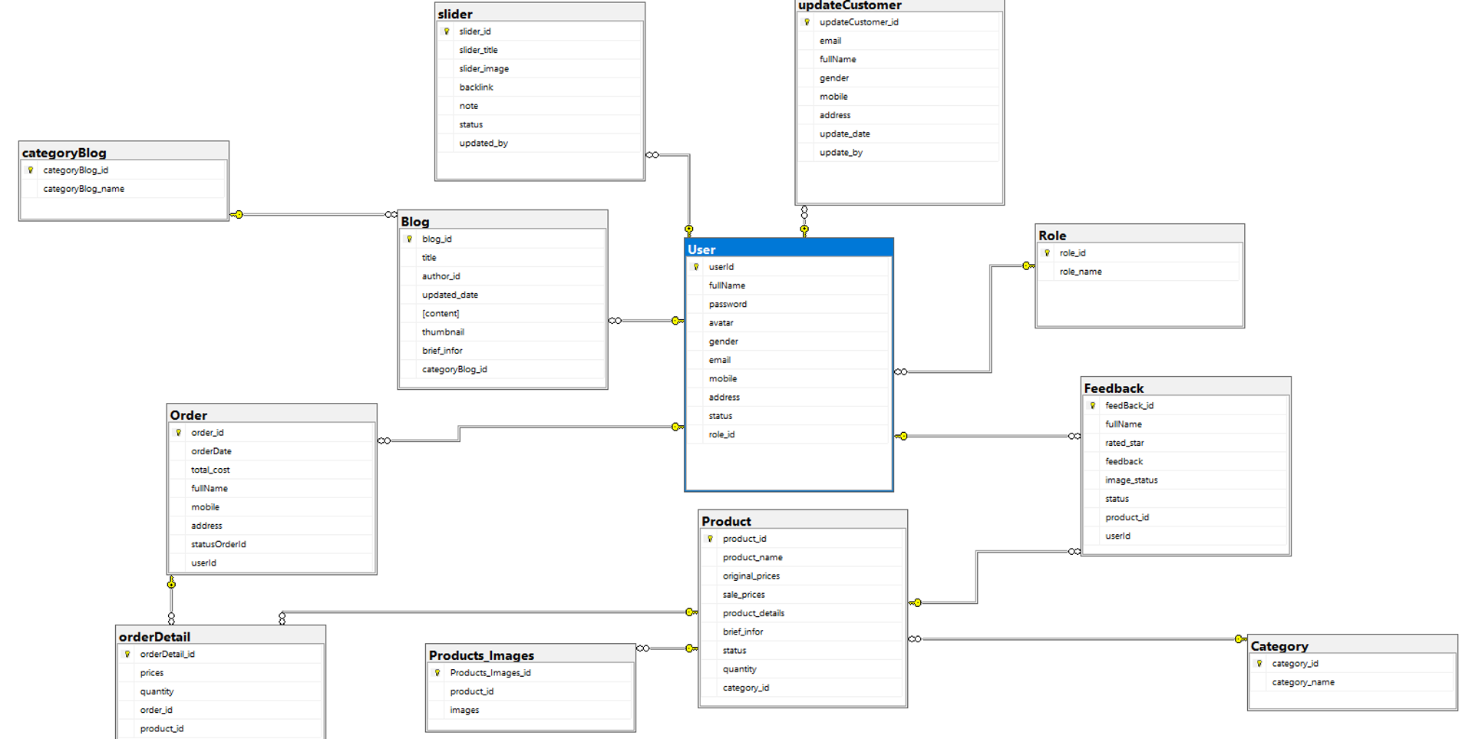

**Table List**

|  |  |  |
| --- | --- | --- |
| **#** | **Table** | **Description** |
| 1 | User | userId int ,  fullName nvarchar(50),  password varchar(50),  avatar varbinary(max),  gender bit,  email varchar(50),  mobile varchar(50),  role_id int,  [address] nvarchar(255),  [status] nvarchar(50)  **Primary key: userId**  **Foreign key: role_id** |
| 2 | Role | role_id int,  role_name varchar(50)  **Primary key: role_id** |
| 3 | Category | category_id int,  category_name nvarchar(50)  **Primary key: category_id** |
| 4 | Product | product_id,  product_name nvarchar(255),  category_id int,  brief_infor  original_prices float,  sale_prices float,  product_details nvarchar(max),  quantity int,  Status nvarchar(50)  **Primary key: product_id**  **Foreign key: category_id** |
| 5 | Product_Images | Product_Images_id int,  Product_id int,  images varchar(max)  **Primary key: statusOrder_id**  **Foreign key: Product_id** |
| 6 | Order | order_id int,  fullName nvarchar(50),  email varchar(50),  mobile varchar(50),  Address nvarchar(255),  orderDate date,  total_cost float,  statusOrder_id int,  user_id int  **Primary key: order_id**  **Foreign key: user_id** |
| 7 | orderDetail | orderDetail_id int,  product_id int,  prices float,  quantity int,  order_id int  **Primary key: orderDetail_id**  **Foreign key:product_id int_id** |
| 8 | Feedback | feedBack_id int,  fullName nvarchar(50),  rated_star float,  feedback nvarchar(max),  image_status varbinary(max),  Status bit,  product_id int,  userId int,  **Primary key: feedBack_id**  **Foreign key: product_id, userId** |
| 9 | categoryBlog | categoryBlog_id int,  categoryBlog_name nvarchar(50)  **Primary key: categoryBlog_id** |
| 10 | Blog | blog_id int,  title nvarchar(50),  author_id int,  updated_date date,  content text,  Thumbnail text,  Brief_infor nvarchar(255)  categoryBlog_id int,  **Primary key: blog_id**  **Foreign key: author_id, categoryBlog_id** |
| 11 | UpdateCustomer | udateCustomer_id int,  email varchar(50),  fullName nvarchar(50),  Gender bit,  mobile varchar(50),  Address nvarchar(255)  updated_date date,  updated_by int,  **Primary key: udateCustomer_id**  **Foreign key: updated_by** |
| 12 | Slider | slider_id int,  slider_title nvarchar(50),  Slider_images text,  Backlink varchar(max),  Note nvarchar(50),  Status int,  update_by int,  **Primary key: slider_id**  **Foreign key: update_by** |

# II. Functional Requirements

## 1. Public Feature

### a. Home Page

● Function trigger: This function is triggered when the user visits the website or the system homepage

● Function description: Users can see interesting posts, featured products, and have a link to that article or product.

● Screen layout: simulated prototype of the screen, the sample below is for the home sc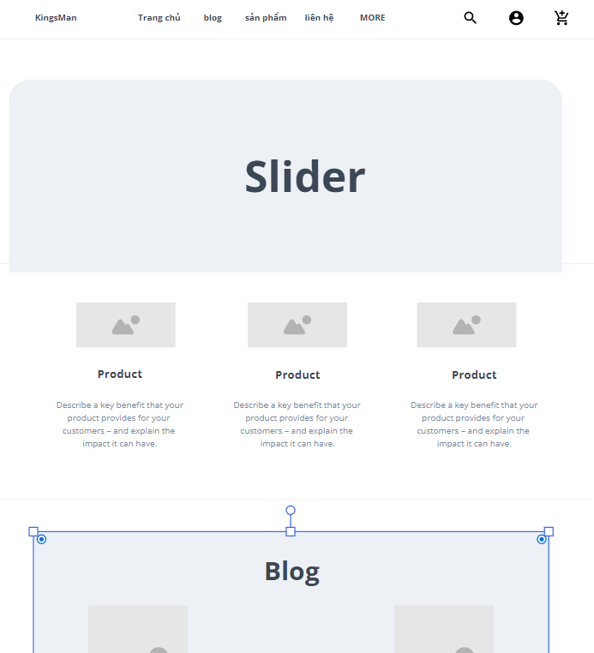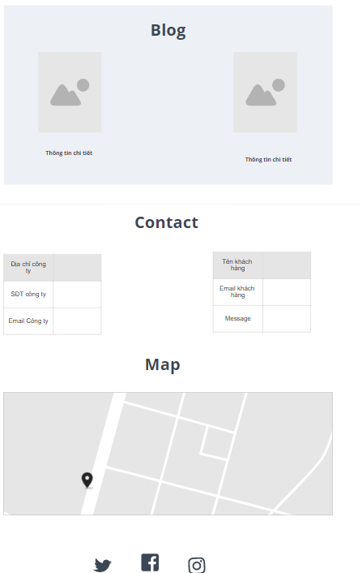

Function description:

* Shown slider information includes its image and title; the user is redirected to the slider's backlink on his/her clicking

- Shown post information includes its thumbnail, title, brief-info; the

user is redirected to the post's details on his/her clicking

- Shown product information includes its thumbnail, title, brief

information; the user is redirected to the product's details on his/her

clicking.

### b. Blog List

…

### c. Blog Details

…

### d. Products List

* *Function trigger: This function is triggered when the user clicks to Product( Sản Phẩm) on header.*
* *Function description: Show the products paginated (sorted by updated date) + the slider with the product search box, product categories, the latest products, and static contacts/links*
  + *Shown product information includes its thumbnail, title, brief information, original price, and sale price.*
  + *The user is redirected to the product's details on his/her clicking on the product.*
  + *The user can choose to add the product to the cart or to feedback on the product by clicking the product's Buy & Feedback buttons responsively.*
* *Screen layout: mockup prototype of the screen, sample below is for Product list screen*

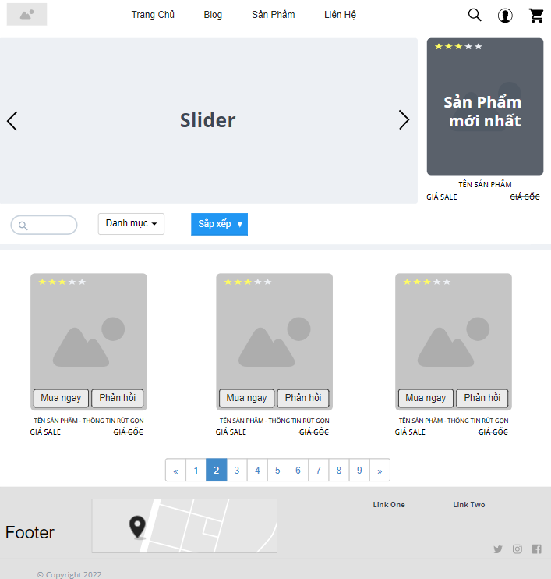

* *Function Details: When the page loads for the first time, it will display all the products, categories, and sliders in the database.*
  + *When clicking on the search bar, the keyword will be transmitted for processing and will return the product page containing that keyword.*
  + *When clicking on the dropdown for the category, selecting a category in it, the page will return products with the same selected category.*
  + *When clicking on the dropdown for sorting, choosing a sort, the page will return the products after being sorted according to that selection.*
  + *Clicking on a specific product will take you to the Product detail screen for that product.*
  + *When clicking buy now, the product will be added 1 time to the cart.*
  + *Clicking on the feedback will be taken to the feedback screen for that product.*

### e. Product Details

### 

### *Activate the function: This function is activated when the user clicks on the Product.*

### *Function Description: Display user clicked products on product page + slider with product search box, product category, latest product and contact/static link*

### *Product information displayed includes thumbnail, title, details, original price and special price, quantity, color, size.*

### 

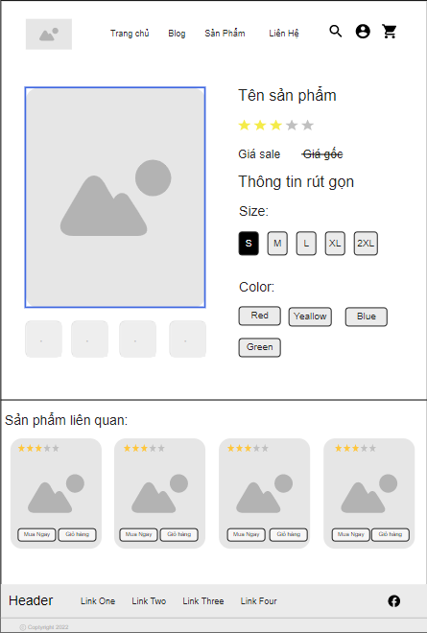

### *The user can choose to make a purchase or add the product to the cart.*

### *Related products displayed by product category have the same functions as in the Product List page*

### *Screen layout: The template above is for product detail, the template below is for related product list screen*

### f. Cart Details

*Trigger function: This function is triggered when user clicks on the cart icon.*

*Function Description: Display user clicked products in header bar + slider with product search box, product category, latest products and contact/static link*

*The product information displayed includes thumbnail, name, original and discounted price, quantity, total price of the unit and total price of the products.*

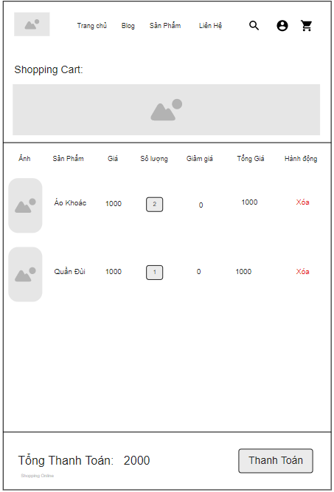

*The user can choose to checkout or remove the product from the cart.*

*Related products are displayed in the order the user clicks add to cart*

*Screen Layout: The template above is for the header of the page, the template below is for the products added to cart screen, and the last one shows the total price details of the products in the cart, to the user. proceed to payment*

### g. Cart Contact

…

### h. Cart Completion

…

### j. Feedback

…

## 2. Common Feature

### a. User Login

*[A function can be a screen or a non-screen function (listed in the part I.2 above). In this part, you need to provide the details on the related function, focus on mentioning below information*

* *Function trigger: how this function is triggered (navigation path, a timing frequency, etc.*
* *Function description: actors/roles, purpose, interface, data processing, etc.*
* *Screen layout: mockup prototype of the screen, sample below is for Manage Products screen*

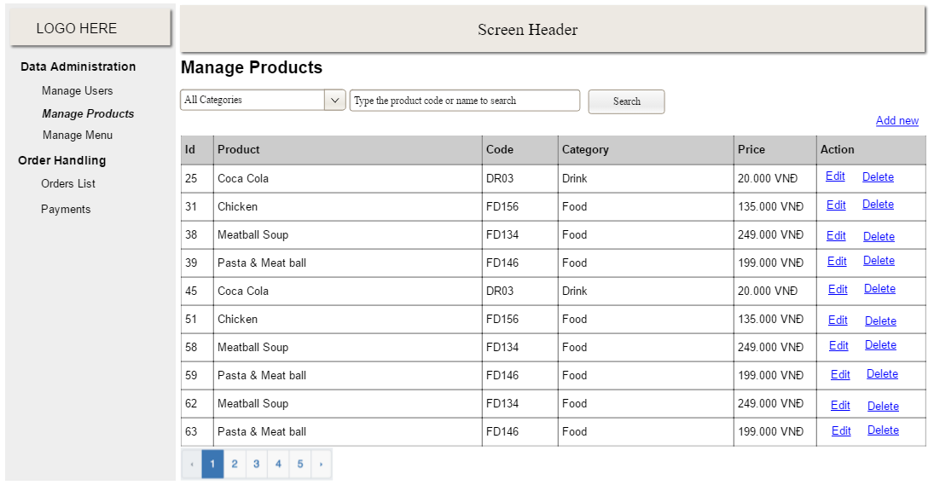

* *Function Details: provide explanation for the data, validation, business logics, functionalities (for both normal cases and abnormal cases), etc. of the function so that the reader can imagine how it works.*

*]*

* **Function trigger:** This function is triggered when the user clicks “Đăng Nhập” form “Trang Chủ”
* **Function description:** User sign in into the system.
* **Screen layout:** mock-up prototype of the screen, sample below is for the Login screen

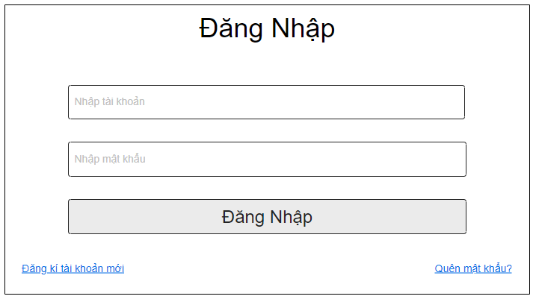

* **Function Details**:
  + When the page loads for the first time, it will display the homepage.
  + When clicking on the login button on the homepage, have a login pop-up.
  + When entering username and password, then click on button login.
  + If username or password are correct, the page will return homepage and have a button logout.
  + If username or password are incorrect, have a notify "Username or password are incorrect"
  + Clicking on "Quên mật khẩu" will take you to the reset password screen for user.
  + Clicking on "Đăng ký" will take you to the register screen for users.

### b. User Register

* **Function trigger:** This function is triggered when the guest goes to login and choose to register
* **Function description:** The guest can create an account.
* **Screen layout:** mock-up prototype of the screen, sample below is for the Register.

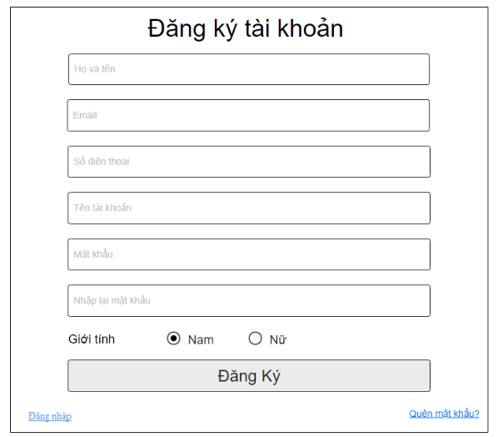

* **Function Details**:
  + When the page loads for the first time, it will display the homepage.
  + When click on button login on homepage, have a login pop-up, and click on button register to have a register pop-
  + When entering username and password, then click on button login.
  + If username or password doesn't exist, the page will return homepage and have a button logout.
  + If username exist, have a notify "Username exist"
  + If password and re-password aren't the same, have a notify "password and re-password are not the same"
  + Clicking on "Quên mật khẩu" will take you to the reset password screen for user.
  + Clicking on "Đăng nhập" will take you to the login screen for the user.

### c. Reset Password

* **Function trigger**: This function is triggered when the user clicks “Quên mật khẩu” form Đăng nhập
* **Function description**: The user can Reset Password to an account.
* **Screen layout**: simulated prototype of screen, below sample is for ResetPassword screen

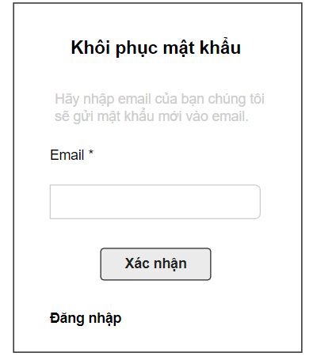

* **Function Details**: User enters his email, clicks "Xác nhận" button to receive password reset link. If email does not exist in the shop, will receive notification and be allowed to re-enter. When entering the correct email registered with the shop, this link is sent to the user's email to reset their password.

- When the link is clicked, the user is directed to the reset password page, where they enter the new password (twice) to access the system and return to the home page

### d. Change Password

* **Function trigger**: This function is triggered when the user clicks “Tài khoản của tôi” from avatar in Homepage
* **Function description**: User to change his password by entering current password as well as new password (twice)
* **Screen layout**: simulated prototype of screen, below sample is for ChangePassword screen

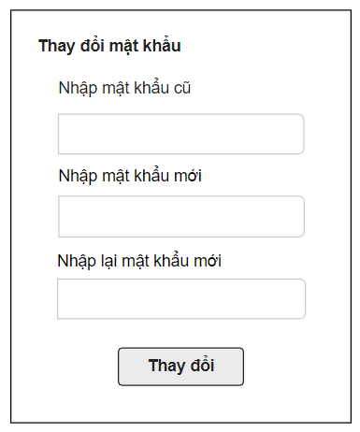

* **Function Details**: User enters the old password and enters the desired new password (twice), then clicks the "Thay đổi" button. If the old password is wrong, or 2 new passwords that are not the same will receive a notification. When the old password is entered correctly and the 2 new passwords are the same, the password change is successful

### e. User Profile

* **Function trigger**: This function is triggered when the user clicks “Tài khoản của tôi” from Home
* **Function description:** The user can edit his/her profile information, including the registered user information and the avatar image.
* **Screen layout:** simulated prototype of screen, below sample is for User profile screen

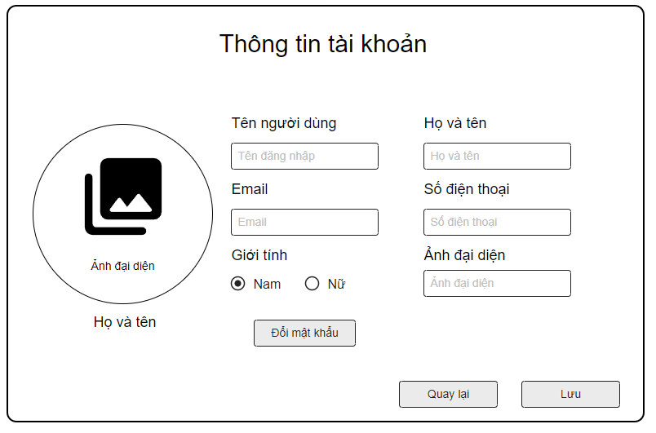

* **Function Details**:
  + The user can edit his/her profile information.
  + Clicking on "Đổi mật khẩu" will take you to the change password screen for user.
  + Clicking on "Lưu" will take you to save information for the user.
  + Clicking on "Quay lại" will take you to the homepage screen for the user.

### f. User Authorization

…

## 3. Admin Feature

### a. Admin Dashboard

*[A function can be a screen or a non-screen function (listed in the part I.2 above). In this part, you need to provide the details on the related function, focus on mentioning below information*

* *Function trigger: how this function is triggered (navigation path, a timing frequency, etc.*
* *Function description: actors/roles, purpose, interface, data processing, etc.*
* *Screen layout: mockup prototype of the screen, sample below is for Manage Products screen*

**

* *Function Details: provide explanation for the data, validation, business logics, functionalities (for both normal cases and abnormal cases), etc. of the function so that the reader can imagine how it works.*

*]*

### b. Users List

…

### c. User Details

…

### d. Settings List

…

### e. Setting Details

…

## 4. Marketing Feature

### a. Posts List

*[A function can be a screen or a non-screen function (listed in the part I.2 above). In this part, you need to provide the details on the related function, focus on mentioning below information*

* *Function trigger: how this function is triggered (navigation path, a timing frequency, etc.*
* *Function description: actors/roles, purpose, interface, data processing, etc.*
* *Screen layout: mockup prototype of the screen, sample below is for Manage Products screen*

**

* *Function Details: provide explanation for the data, validation, business logics, functionalities (for both normal cases and abnormal cases), etc. of the function so that the reader can imagine how it works.*

*]*

### b. Post Details

…

### c. Sliders List

…

### d. Slider Details

…

### e. Products List

…

### f. Product Details

…

### g. Customers List

…

### h. Customer Details

…

### j. Feedbacks List

…

### k. Feedback Details

…

## 5. Customer Feature

### a. My Orders

*[A function can be a screen or a non-screen function (listed in the part I.2 above). In this part, you need to provide the details on the related function, focus on mentioning below information*

* *Function trigger: how this function is triggered (navigation path, a timing frequency, etc.*
* *Function description: actors/roles, purpose, interface, data processing, etc.*
* *Screen layout: mockup prototype of the screen, sample below is for Manage Products screen*

**

* *Function Details: provide explanation for the data, validation, business logics, functionalities (for both normal cases and abnormal cases), etc. of the function so that the reader can imagine how it works.*

*]*

### b. Order Information

…

## 6. Sale Feature

### a. Sale Dashboard

*[A function can be a screen or a non-screen function (listed in the part I.2 above). In this part, you need to provide the details on the related function, focus on mentioning below information*

* *Function trigger: how this function is triggered (navigation path, a timing frequency, etc.*
* *Function description: actors/roles, purpose, interface, data processing, etc.*
* *Screen layout: mockup prototype of the screen, sample below is for Manage Products screen*

**

* *Function Details: provide explanation for the data, validation, business logics, functionalities (for both normal cases and abnormal cases), etc. of the function so that the reader can imagine how it works.*

*]*

### b. Orders List

…

### c. Order Details

…